Anthony Le

ST 511

10/11/16

Homework 2

***Question 1***

Exercise 20:

1. $s_{2}=3.184785, m_{2}=-1.142857; DF=6$ is associated with the sample standard deviation, s2.

The p-value of 0.3791 is greater than the usual level of significance, 0.05. So, it fails to reject the null hypothesis, and conclude that there is insufficient evidence to indicate that the mean reduction group is different from zero. A 95% confidence interval for the difference is from $\text{-4.088292 to 1.802578 mmHg}$.

Exercise 21:

There is insufficient evidence to indicate that the mean difference in humerus length between survived moribund male house sparrows and perished moribund male house sparrows is nonzero (two-sided p-value = 0.0809 from a two-sample t-test).

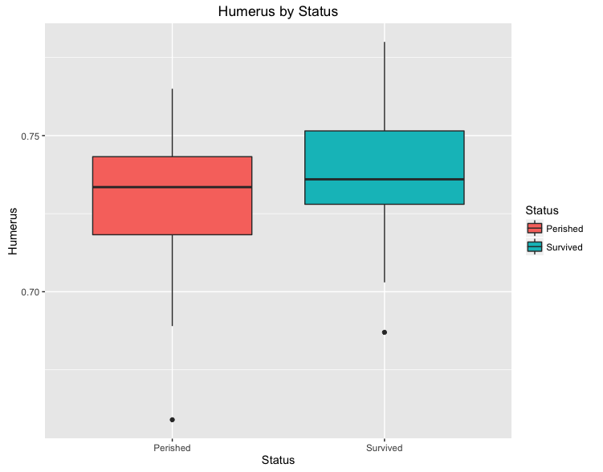

It is estimated that mean humerus length is only 0.0101 inches greater in the survived moribund male house sparrows than the perished moribund male house sparrows. A 95% confidence interval for the difference is from 0.00128 to 0.0214 inches.

***Question 2***

1. The sampling distribution of the sample standard deviation is the distribution of the sample standard deviations, with all the samples having the same sample size n taken from the same population. The standard deviation of each sample from that given population is determining by first calculating the mean of each sample, then the variance of each sample, and finally, calculating the standard deviation of each sample (square root of the variance). The collection of sample standard deviations is the sampling distribution of the sample standard deviation.
2. The mean of the sampling distribution of the sample standard deviation is the average of all the sample standard deviations from the samples having the same sample size n from the same population. The mean of the sampling distribution of the sample standard deviation is calculated by adding up all the sample standard deviations and dividing that sum by the number of samples taken from the given population.